|  |  |  |  |  |  |  |  |  |  |  |  |  |
| --- | --- | --- | --- | --- | --- | --- | --- | --- | --- | --- | --- | --- |
| |  |  | | --- | --- | | **Semester One Examination 2018** |  | | **Question/Answer Booklet** |   **12 ATAR PHYSICS**   |  |  |  | | --- | --- | --- | | Student  Number: | In  Figures |  | |  | In words |  | | **Name** |  |  | |
|  |

**Time allowed for this paper**

Reading time before commencing work: Ten minutes

Working time for paper: 180 minutes

**Materials required/recommended for this paper**

***To be provided by the supervisor***

This Question/Answer Booklet Formulae and Data Booklet

***To be provided by the candidate***

Standard items: pens (blue/black preferred), pencils (including coloured), sharpener, correction tape/fluid, eraser, ruler and highlighters

Special items: non-programmable calculators approved for use in the WACE examinations, drawing templates, drawing compass and a protractor

**Important note to candidates**

No other items may be taken into the examination room. It is your responsibility to ensure that you do not have any unauthorised notes or other items of a non-personal nature in the examination room. If you have any unauthorised material with you, hand it to the supervisor before reading any further.

**Structure of this paper**

|  |  |  |  |  |  |
| --- | --- | --- | --- | --- | --- |
| Section | Number of questions available | Number of questions to be answered | **Suggested** working time (minutes) | Marks available | Percentage of exam |
| Section One: Short answers |  |  |  |  |  |
| Section Two: Problem-solving | 6 | 6 | 90 | 90 | 50 |
| Section Three: Comprehension |  |  |  |  |  |
|  |  |  |  | Total | 100 |

**Instructions to candidates**

1. Write your answers in this Question/Answer Booklet.
2. When calculating numerical answers, show your working or reasoning clearly and neatly. Give final answers to **three significant figures** and include appropriate units where applicable.

When estimating numerical answers, show your working or reasoning clearly. Give final answers to a maximum of two significant figures and include appropriate units where applicable.

1. You must be careful to confine your responses to the specific questions asked and to follow any instructions that are specific to a particular question.
2. The Formulae and Data Booklet is available separately and not in the Question/Answer Booklet.

**Section One. Short responses. XX% (XXMarks)**

Attempt **ALL TWELVE (12)** questions in this section. Marks for each question are clearly identified.

**­­­­­­­­­________________________________________________________________**

**Question 1 TO XX (? marks)**

By IW

**Section Two: Problem-solving 50% (90 Marks)**

This section has **seven (7)** questions. Answer **all** questions. Write your answers in the spaces provided. When calculating numerical answers, show your working or reasoning clearly. Give final answers to **three** significant figures and include appropriate units where applicable.

When estimating numerical answers, show your working or reasoning clearly. Give final answers to a maximum of **two** significant figures and include appropriate units where applicable.

Supplementary pages for the use of planning/continuing your answer to a question have been provided at the end of this Question/Answer booklet. If you use these pages to continue an answer, indicate at the original answer where the answer is continued, i.e. give the page number.

Suggested working time: 90 minutes.

**Question 1 (15 marks)**

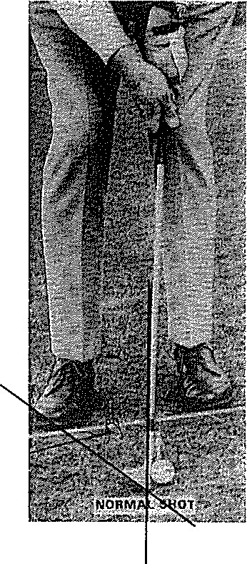

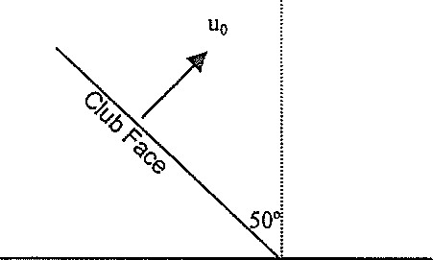

Green

D

A wedge is a golf club designed to hit the ball over short distances. When correctly hit, the ball does not roll when it arrives at its destination, the green. The green, or putting green, is the culmination of a golf hole, where the [flagstick](https://www.thoughtco.com/flagstick-role-in-golf-1560846) and [hole](https://www.thoughtco.com/different-meanings-of-hole-in-golf-1560880) are located. Getting the golf ball into the hole on the putting green is the object of the game of golf.

To do this, the club face is lofted. This means that the club face is inclined at 500 to the vertical as shown in the diagram above **(not drawn to scale).**

Assume that when hit, the ball leaves the club face **at right angles** to the face. The **horizontal distance of ball from launch point to putting green** is shown as **D**.

1. Write expressions giving the horizontal and vertical components of the ball's initial

velocity u0. (2 marks)

1. In terms of u0, t or D calculate each of the following, using appropriate equations:
2. the horizontal distance travelled by the ball after a time t. (2 marks)
3. the height of the ball at any time t. (2 marks)
4. **the horizontal distance from the ball to the green** at any time t. (2 marks)

Tiger Smith, a champion golfer, is 100 m from the hole which is in the centre of the green. His wedge has a loft of 500 with the vertical.

With equations derived in (b) or otherwise, find

c) (i) the velocity with which the ball must leave the club and (2 marks)

(ii) the time the ball is in the air. (2 marks)

d) There is a large tree, 21 m tall, between Tiger and the green. If the green is 70 m

from Tiger, determine with calculations if the ball will clear the tree. (3 marks)

**Question 2 (15 marks)**

The Kepler NASA mission aims to search for planets orbiting stars in other solar systems. The star named Kepler 20 has been observed to have several planets orbiting it. Kepler 20 is 950 light-years from Earth.

Information about Kepler 20 and some of the planets orbiting it is summarised in the table below.

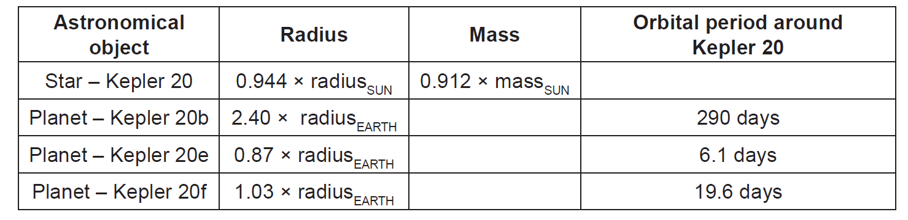

(a) A light-year is an astronomical unit of distance. It is defined as the distance

travelled by light in one year. Calculate the distance from Kepler 20 to Earth in

kilometres. (2 marks)

(b) Astronomers express the mass of Kepler 20 as (0.912 ± 0.035) × massSUN.

Calculate the maximum value astronomers expect for the mass of Kepler 20.

(2 marks)

(c) Calculate the orbital radius of Kepler 20e around Kepler 20. You should use

the mass for Kepler 20 quoted in the table and assume the orbit is circular.

(4 marks)

(d) The mass of Kepler 20b is unknown but it has been speculated that it may

have a density similar to that of Earth, 5520 kg m-3. Calculate the surface

gravity of Kepler 20b if its density is 5520 kg m-3. (4 marks)

Reminder:

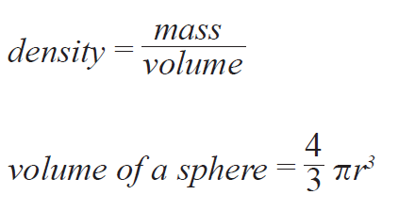

The Kepler mission is particularly concerned with finding planets that lie within the habitable zones of stars. A planet in a star’s habitable zone receives the right amount of energy from the star to maintain liquid water on its surface, provided it also has an appropriate atmosphere.

(e) By comparing the Kepler 20 system and our own solar system, suggest which

planet in the Kepler 20 system is most likely to lie in the habitable zone. Explain your answer. (3 marks)



**THIS PAGE IS LEFT INTENTIONALLY BLANK**

**Question 3 (15 marks)**

**An astronaut on a distant planet** performs a “loop-the-loop” experiment. She releases a 1.3 kg cart from a height of 4.50 m. Assume any friction between cart and track is negligible.

The **gravitational field strength of the distant planet** is gplanet.

The **speed of the cart at the top of the loop** is vtop.

It is observed that the track exerts a normal reaction force of 21 N on the cart at the top of the loop.

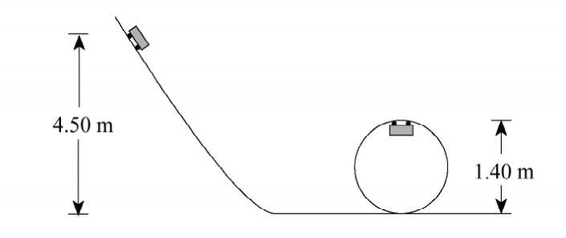

a) Draw and label clearly the forces acting on the cart at the top of loop.

(2 marks)

b) The astronaut derived the equation (vtop)2 = 5.3 gplanet

Using physics principles and calculations, justify clearly if you agree with the astronaut. (5 marks)

1. Calculate the gravitational field strength on the distant planet using your physics understanding of vertical circular motion. (4 marks)
2. The astronaut has returned to Earth and is designing a racetrack. The racetrack surface has the shape of an inverted cone on which cars race in horizontal circle shown below.

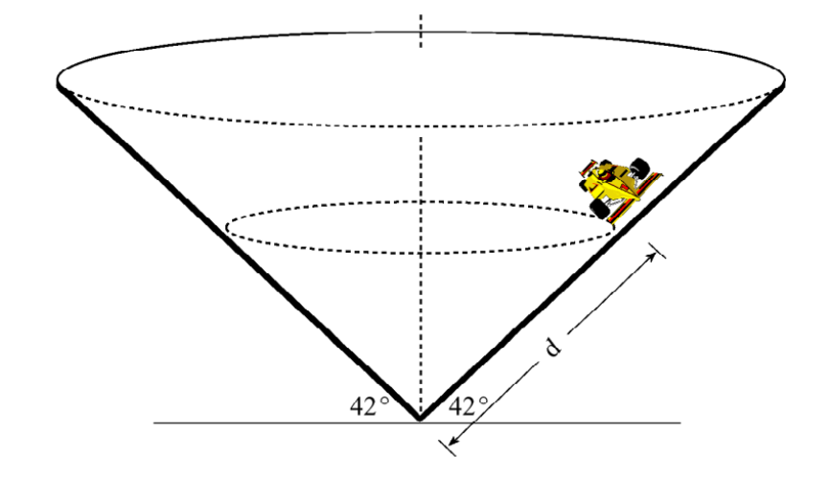

For a steady speed of 29 m s-1, calculate the distance **d,** a driver should drive her car if she wishes to stay on a circular path without friction? (4 marks)

**Question 4 (15 marks)**

A person bending forward to lift a load with his “back” rather than with his “knees” can be injured by the large forces acted on the back muscles and vertebrae.

To consider the magnitude of the forces involved in such poor lifting practices, consider the simplified diagram for a person lifting a 25.0 kg load (L) below.

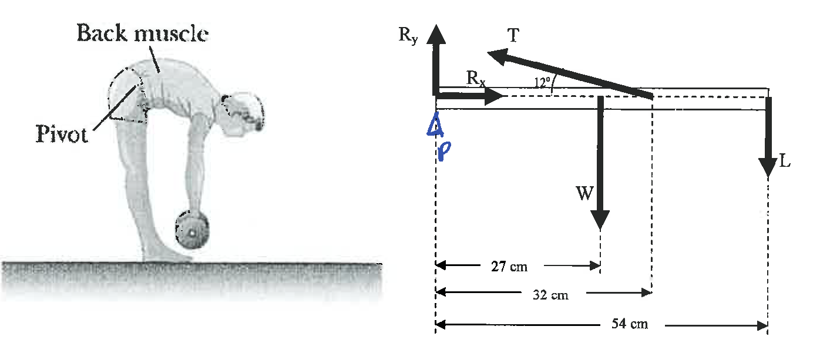

The spine and upper body are represented as a uniform horizontal rod of 41.5 kg (W) pivoted at the base of the spine (P). The erector spinalis muscle acts at an angle to horizontal of 120 to maintain the position of the back. The components of the reaction force (Rx) and (RY) are also shown on diagram.

a) Determine the tension (T) in the erector spinalis muscle while in this position.

(4 marks)

b) Determine the **horizontal component of the reaction force on the spine**

**(Rx)** while in this position. (2 marks)

c) Determine the **vertical component of the reaction force on the spine (RY)**

while in this position. (3 marks)

d) Determine **the reaction force on the spine (R) (which is not shown on the**

**diagram)** while in this position. (3 marks)

1. Describe and justify three strategies using physics principles for a person to lift heavy objects. (3 marks)



**THIS PAGE IS LEFT INTENTIONALLY BLANK**

**Question 5 (15 marks)**

The schematic diagram below shows an electric motor that produces a magnetic field from field coils on either side of the armature coil. It is called a series-wound motor because the field coils X and Y are wired in series with the armature coil.

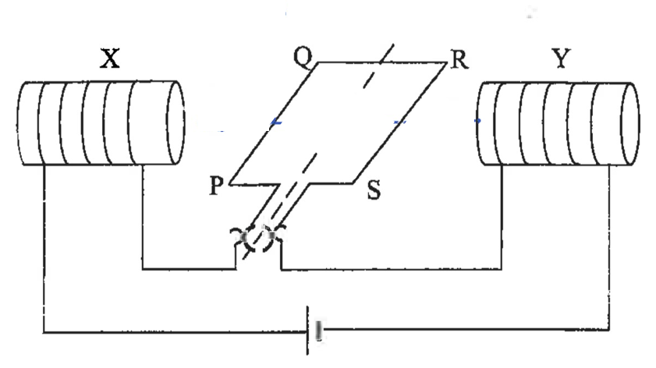

* The armature coil of the motor has 150 turns.
* Side PQ is 5.0 cm long and side QR is 4.0 cm long.
* A 12 V supply provides a current of 0.75 A and generates a 0.095 T magnetic field across the armature coil.

1. i) Draw and label (B) the direction of the magnetic field. (1 mark)

ii) Draw and label (F) the direction of the force of side PQ. (1 mark)

b) Calculate the force on the side RS of the armature. (3 marks)

c) Sketch the graph below of the force on the side PQ (vertical axis) versus time t (horizontal axis) for this simple motor.

For the time axis, show time from time t = 0 to 1.75 T where T is the motor’s period. (2 marks)

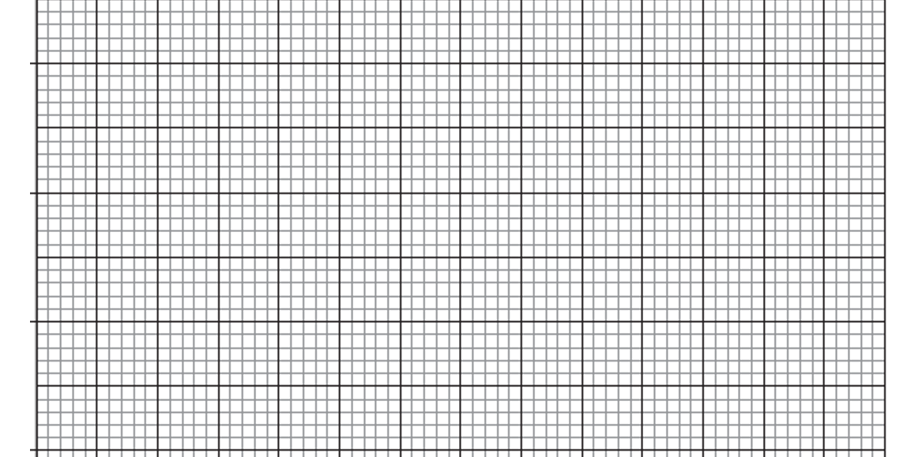

d) Determine the torque produced when the plane of the armature coil is at an

angle of 300 to the magnetic field. (3 marks)

e) Describe and explain two practical ways in which the motor can be modified to produce a greater torque. (2 marks)

1. One advantage of this type of motor is that it works on either AC or DC electrical supplies. Using either or both diagrams below as part of your answer, explain why and how this motor will turn with respect of the type of electrical supply provided. (3 marks)

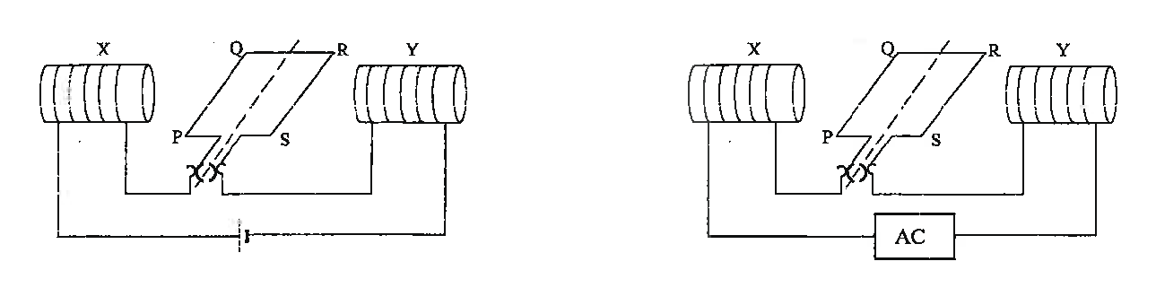



**Question 6 (15 marks)**

The Earth’s moon has always been of primary interest to astronomers and this lead to one of the most significant achievements of the 20th century – Man landing on the Moon.

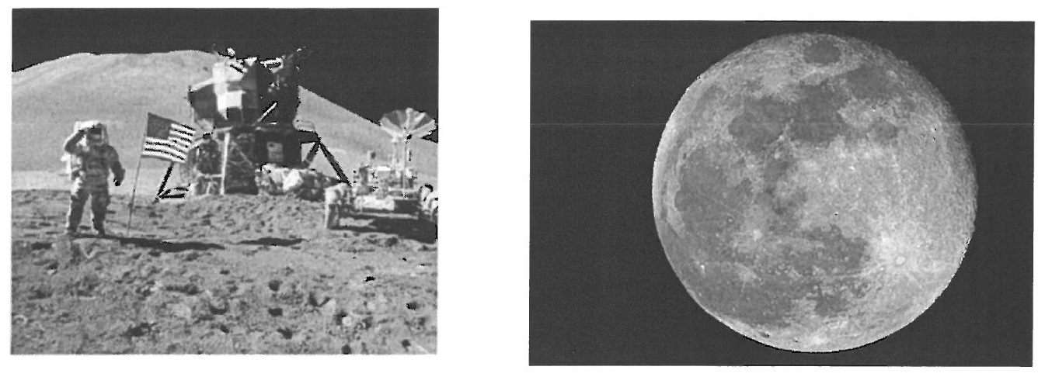

a) Calculate the period for the Moon in orbit around the Earth. (5 marks)

1. An important aspect of the Apollo Lunar landing missions was the return of the Lunar Landing Module (LM) to the orbiting Command Service Module (CSM) before returning to the astronauts to Earth.

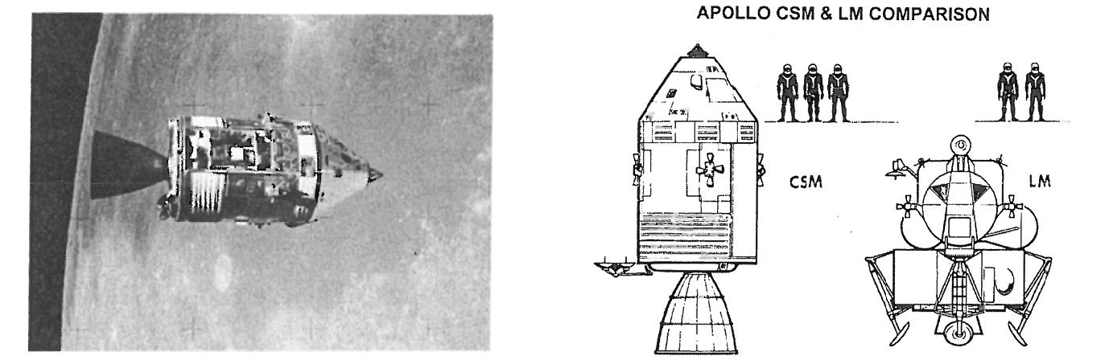

**Determine the height above the Moon’s surface** for which an orbit will effectively allow a Command Service Module to remain “fixed” above the Landing Module situated on the Moon’s surface. (6 marks)

Assume the period of rotation of the Moon is 27.3 days.

1. On the diagrams below, carefully illustrate and indicate direction of a polar orbit and a geostationary orbit. (4 marks)

 

END OF SECTION TWO

**THIS PAGE IS LEFT INTENTIONALLY BLANK**